Task 3– IPL SQL Analysis: 50 Questions

Part A — Basic Queries and Filtering
1. Display the first 10 records from the matches table.
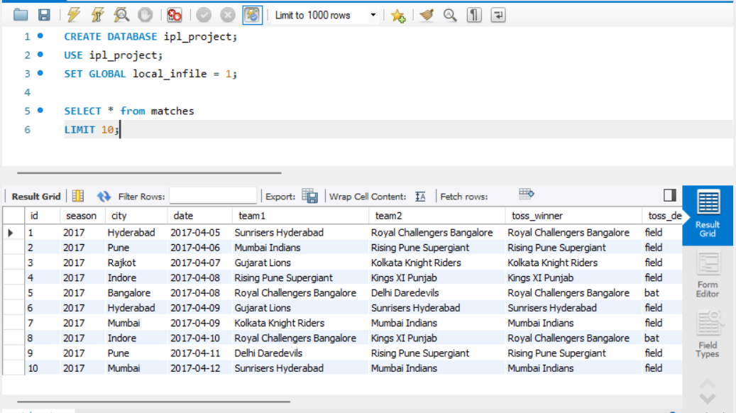

2. Display the first 10 records from the deliveries table.
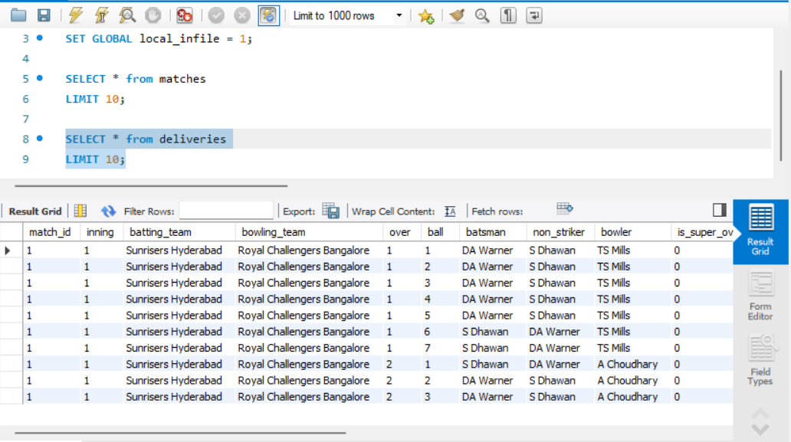

3. Count the total number of rows in the matches table.
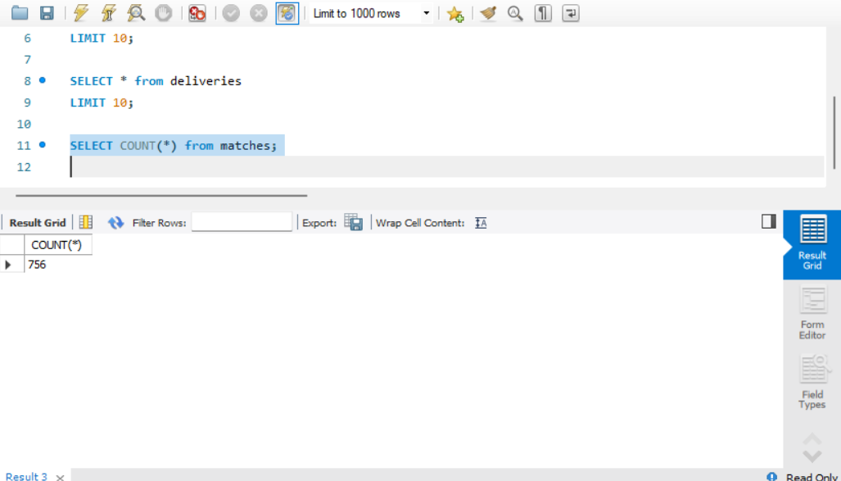

4. Count the total number of rows in the deliveries table.
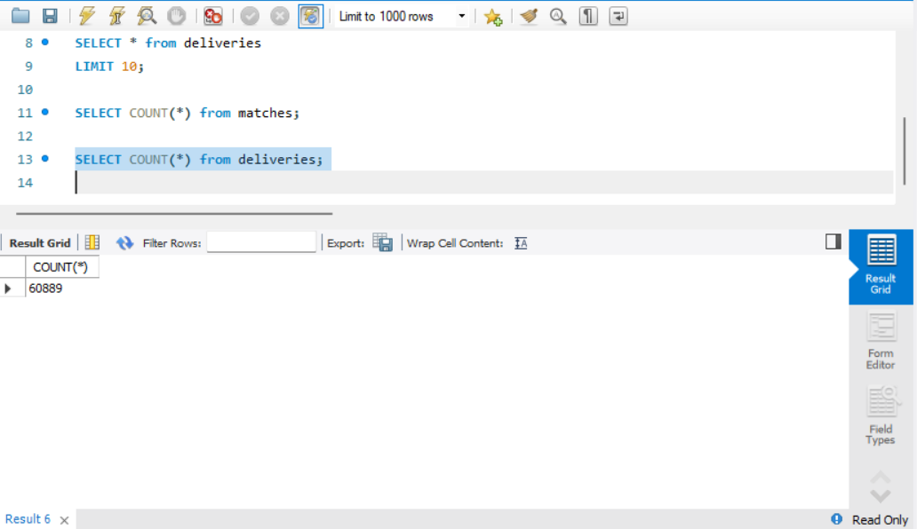

5. Display all unique IPL seasons from the matches table.
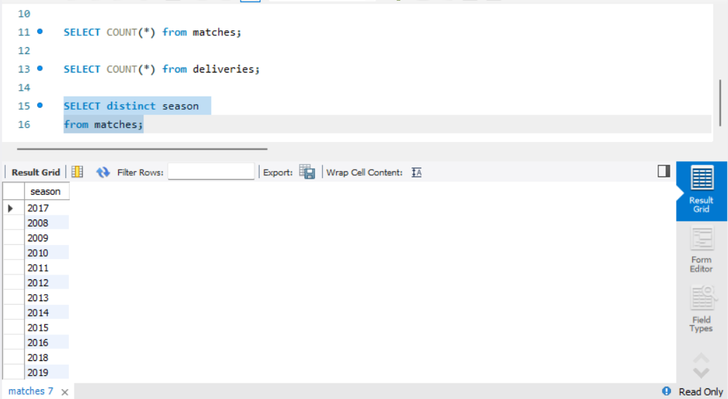

6. Display all unique cities where IPL matches were played
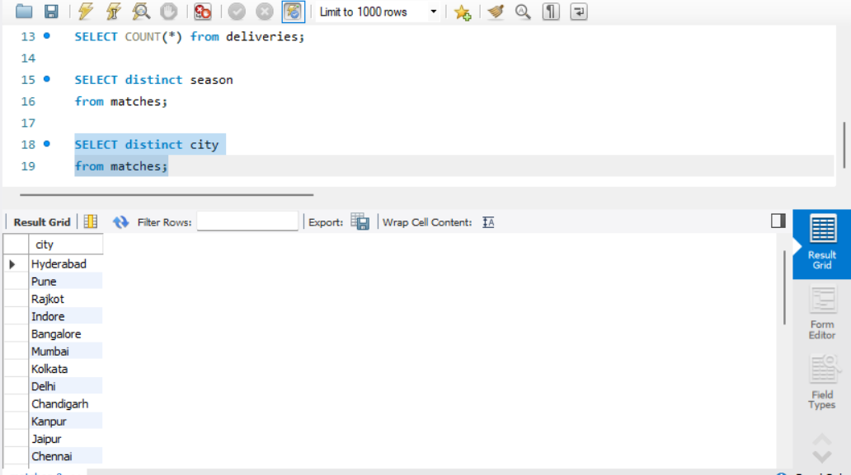

7. Display all unique team names appearing in the team1 column.
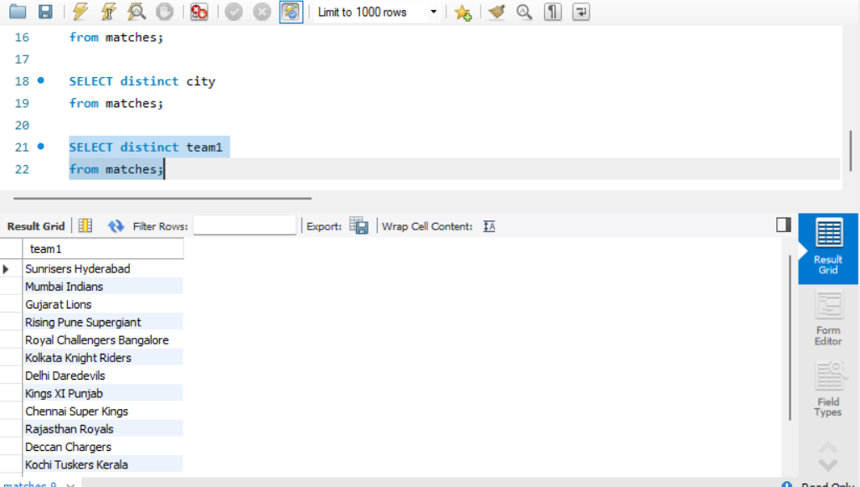

8. Display all matches played in the 2017 season.
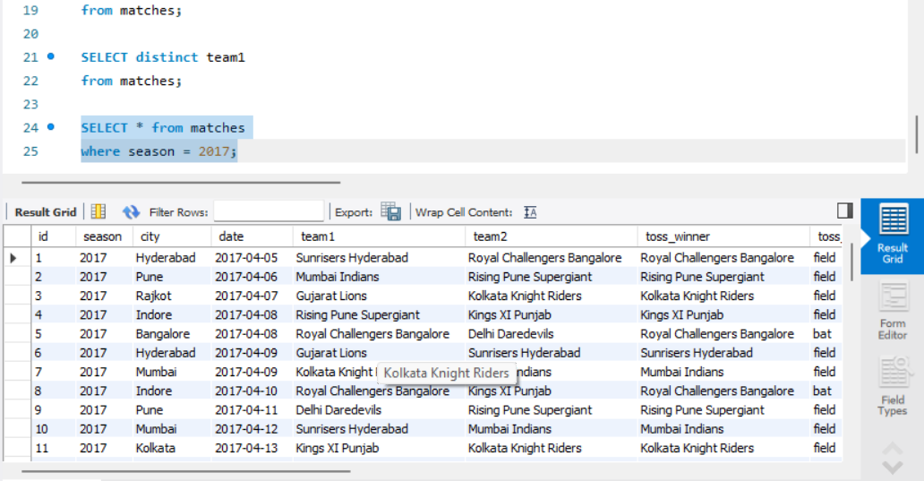

9. Display all matches where the toss decision was field.
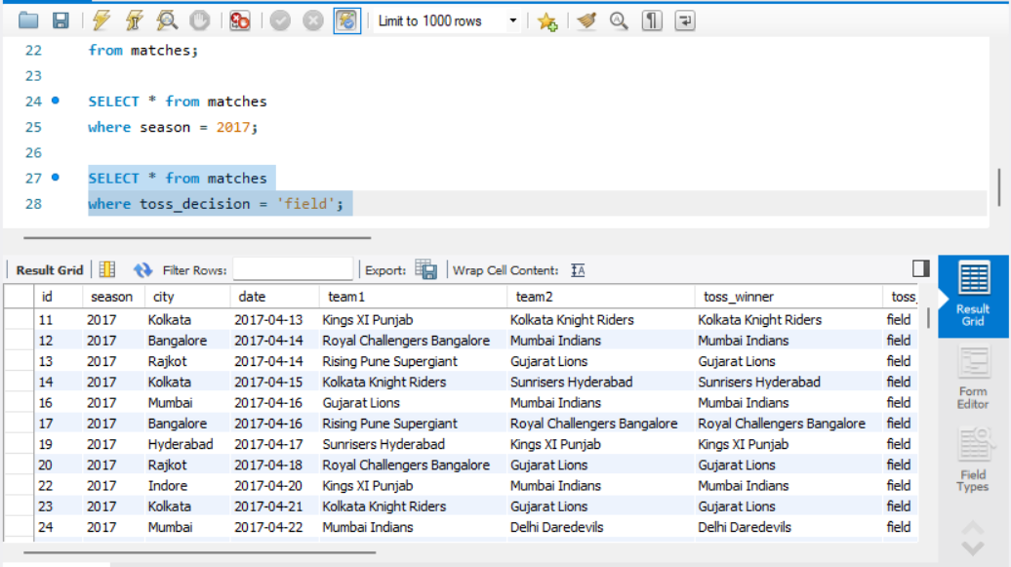

10. Display all matches won by Mumbai Indians
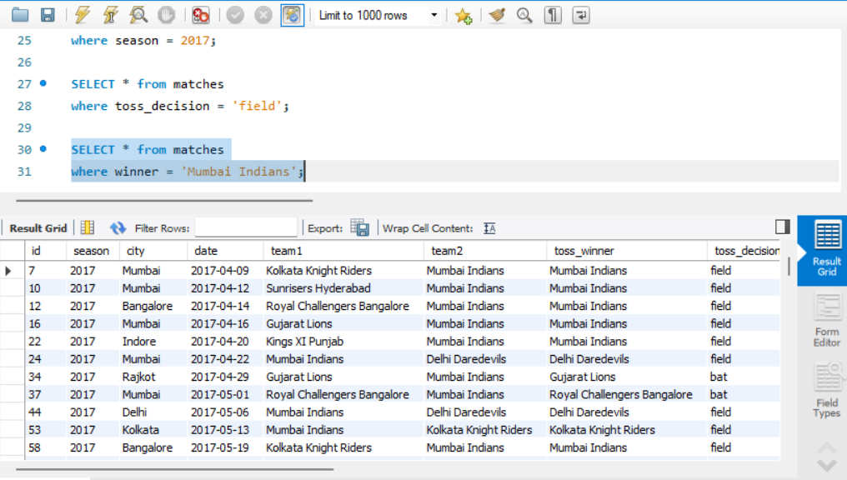

11. Display matches where win_by_runs is greater than 50.
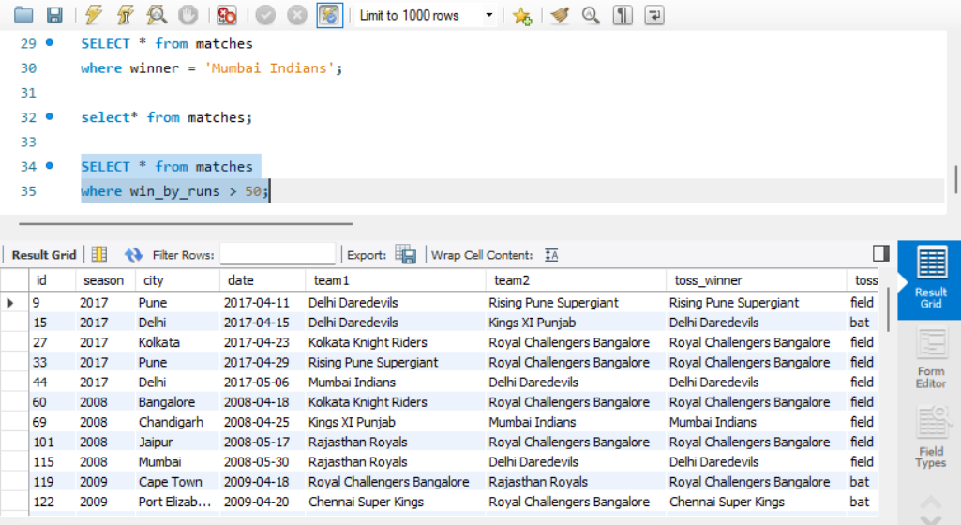

12. Display matches where win_by_wickets equals 10.
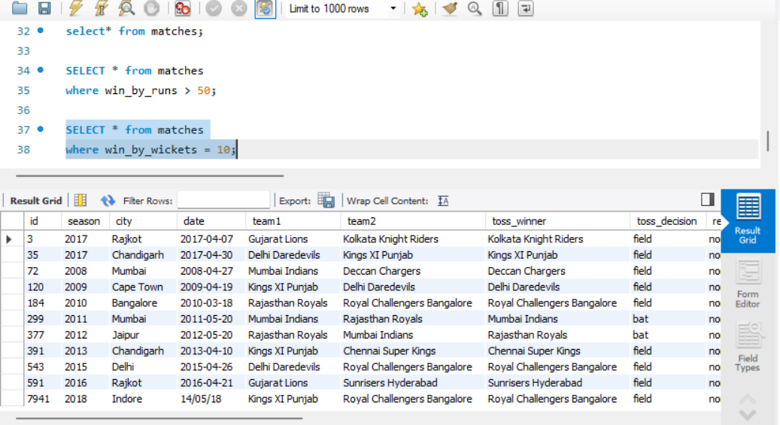

13. Display matches where the toss winner and match winner are the same team.
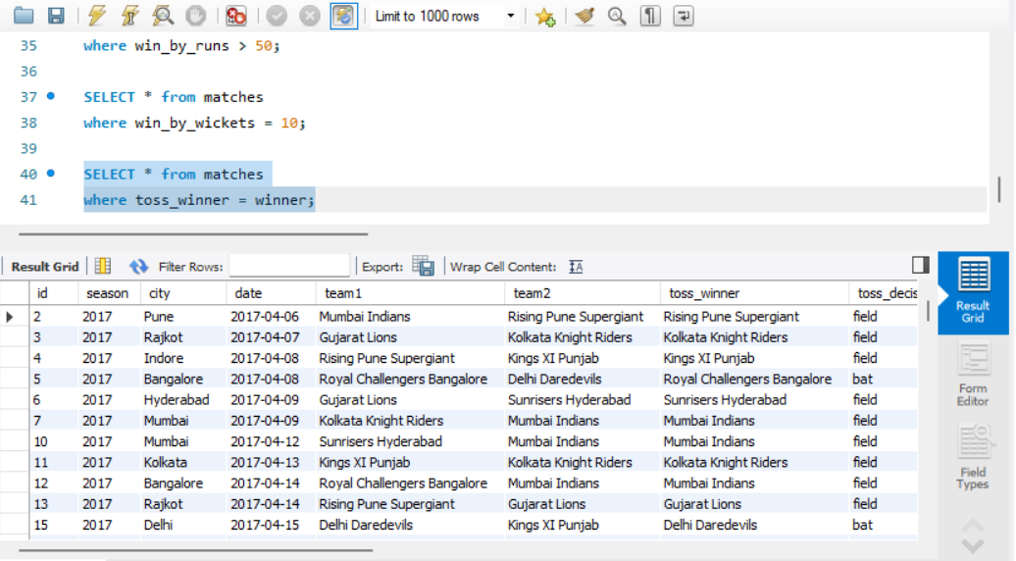

14. Display matches where Mumbai Indians appears as either team1 or team2.
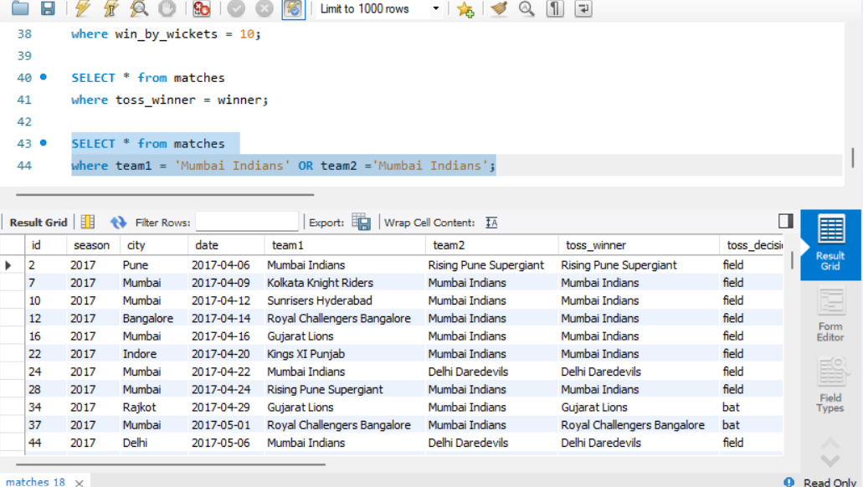

15. Display the 10 matches with the highest win_by_runs values.
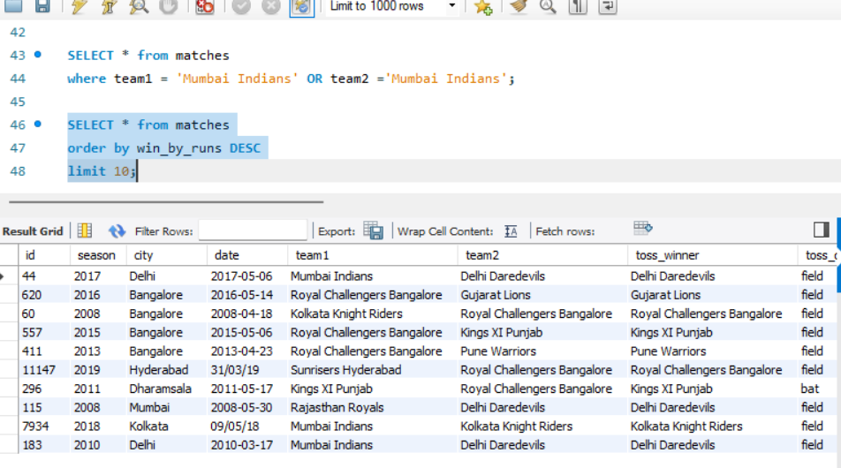

16. Display the 10 matches with the highest win_by_wickets values
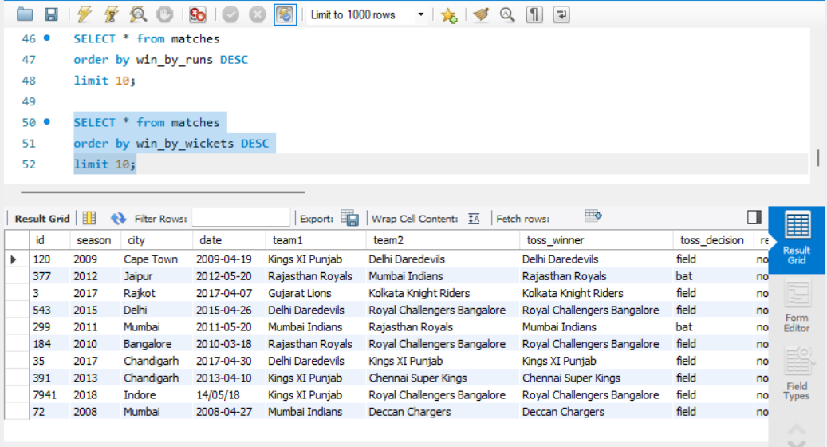

Part B — Grouping and Aggregation
17. Count the number of matches played in each season.
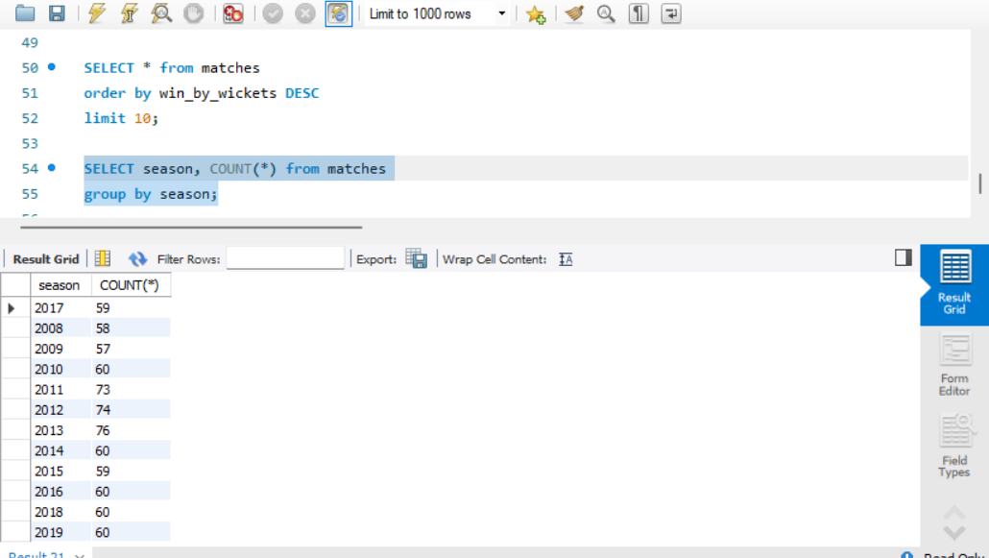

18. Count the number of matches played in each city.
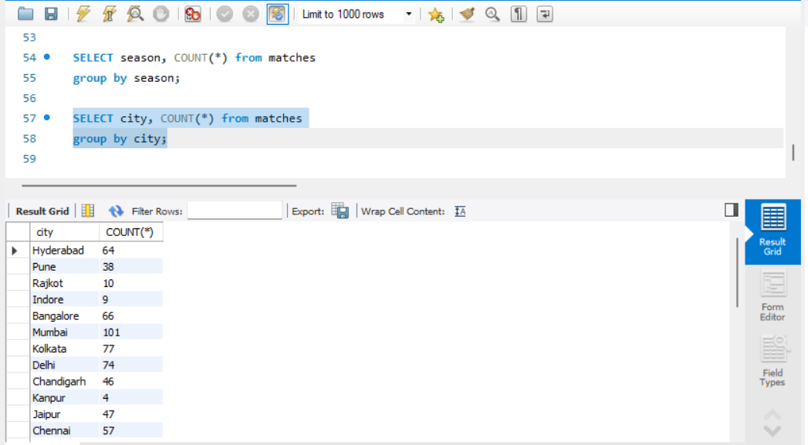

19. Count the number of matches played at each venue.
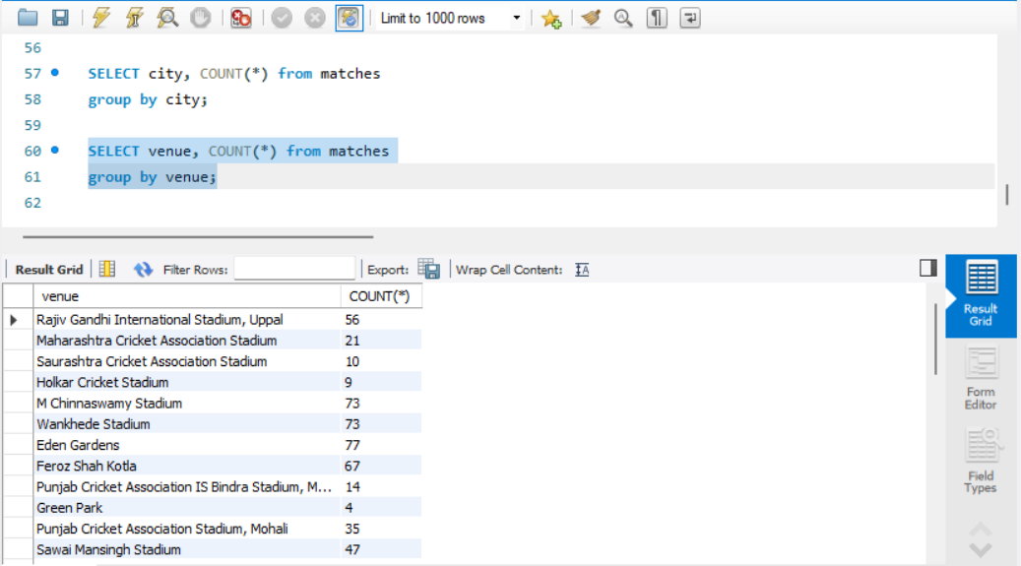

20. Count the number of matches won by each team.
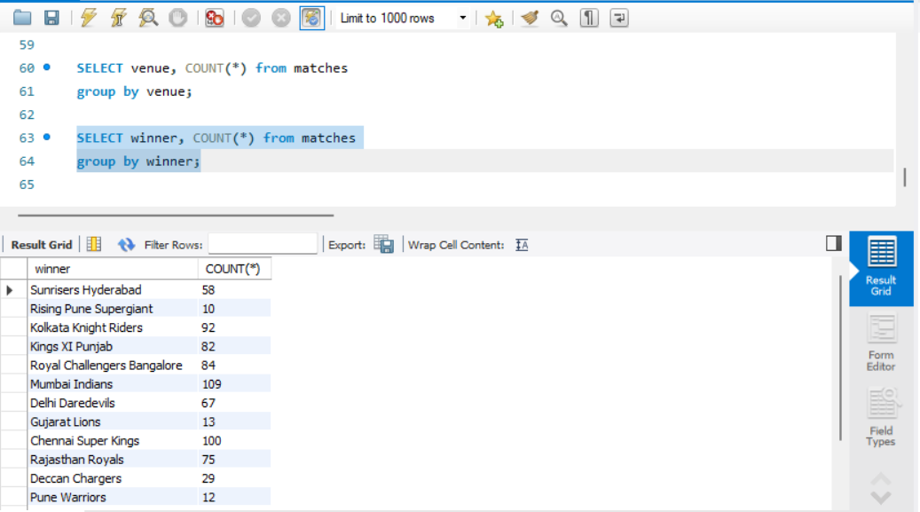

21. Count the number of times each team won the toss.
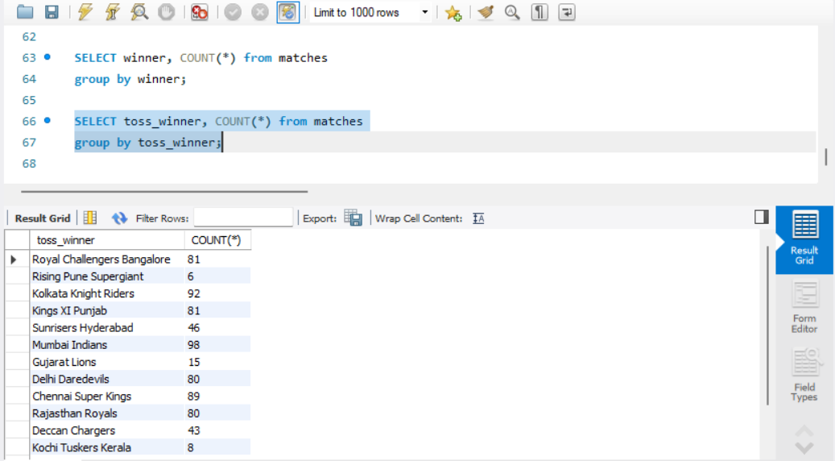

22. Count the number of bat and field toss decisions.
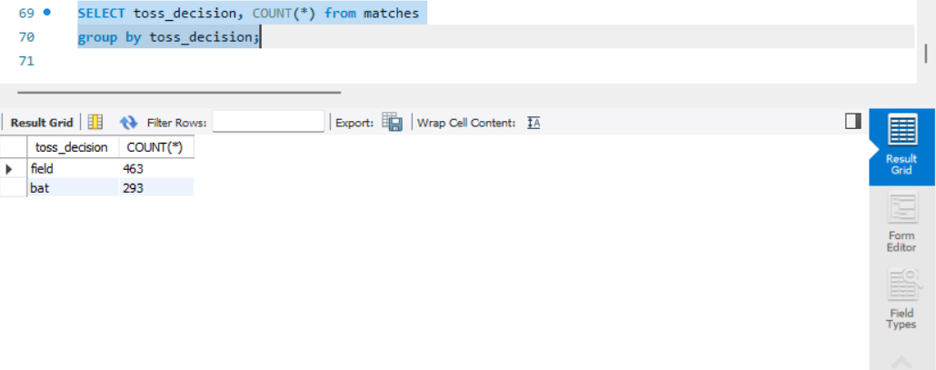

23. Find the top 10 players with the most Player of the Match awards.
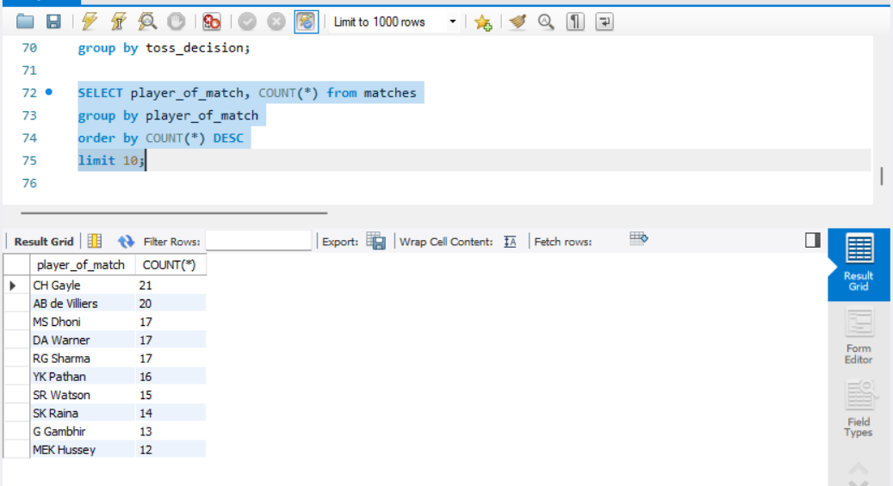

24. Find the average win_by_runs for each season.
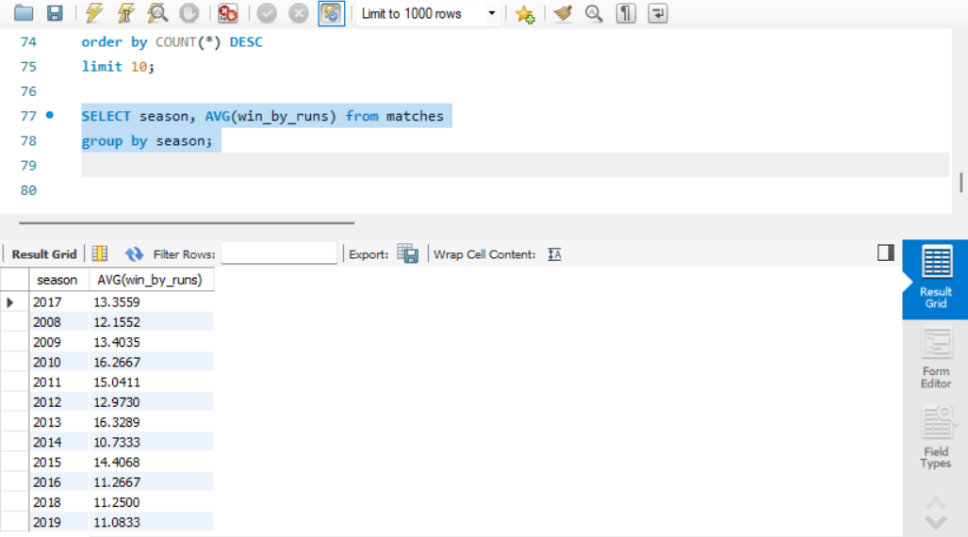

25. Find the average win_by_wickets for each season.
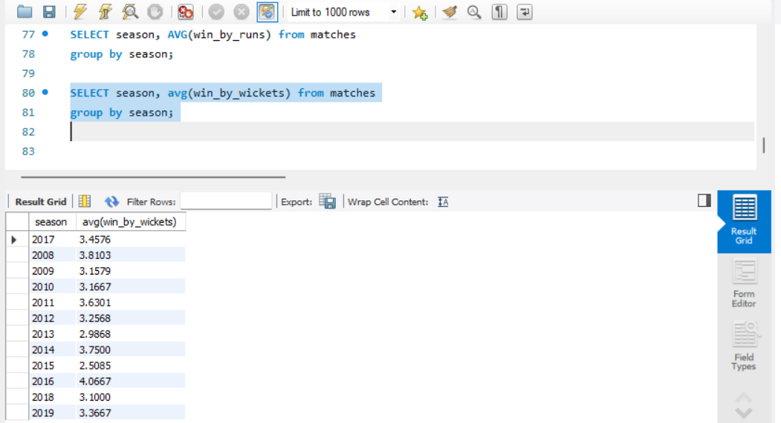

26. Find the maximum win_by_runs recorded in each season.
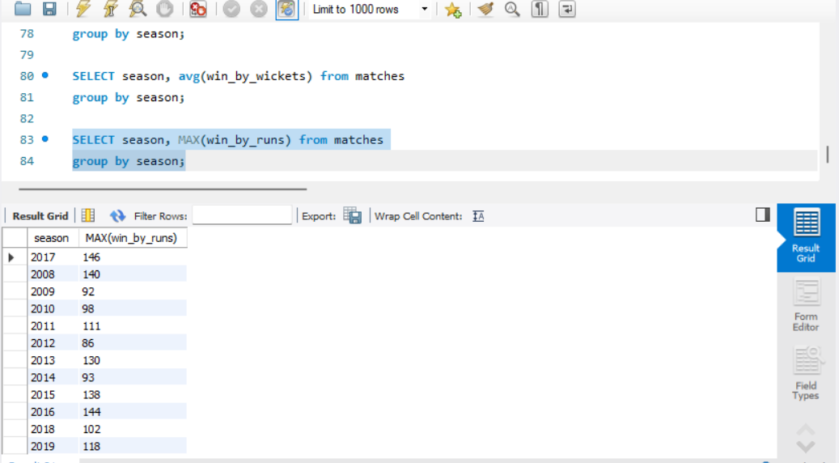

27. Find the maximum win_by_wickets recorded in each season.
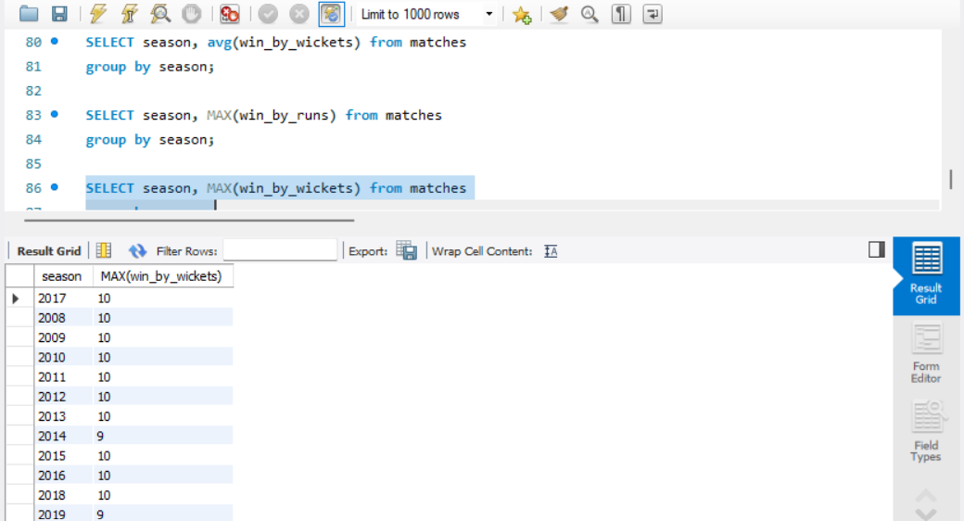

Part C — Ball-by-Ball Analysis

28. Count the total number of sixes (batsman_runs = 6) in the deliveries table.
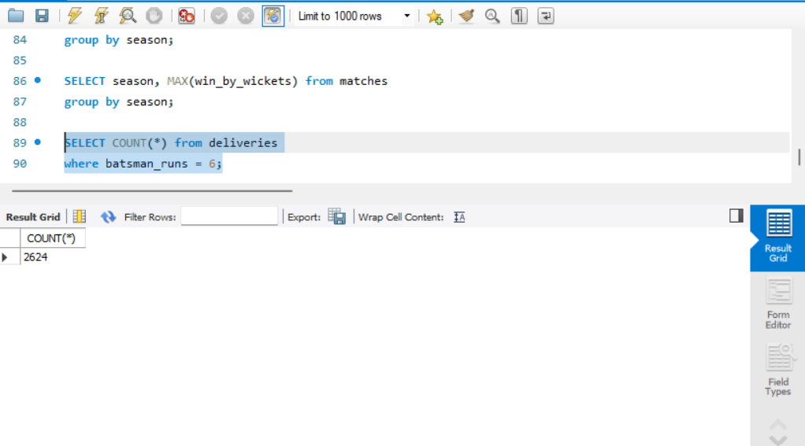

29. Count the total number of fours (batsman_runs = 4) in the deliveries table
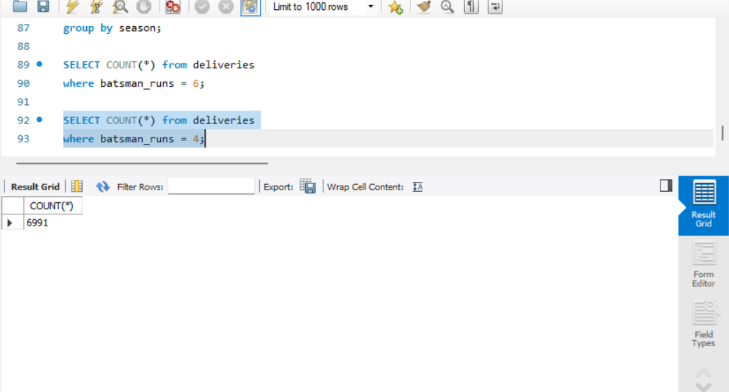

30. Find the total number of wide runs in the deliveries table.
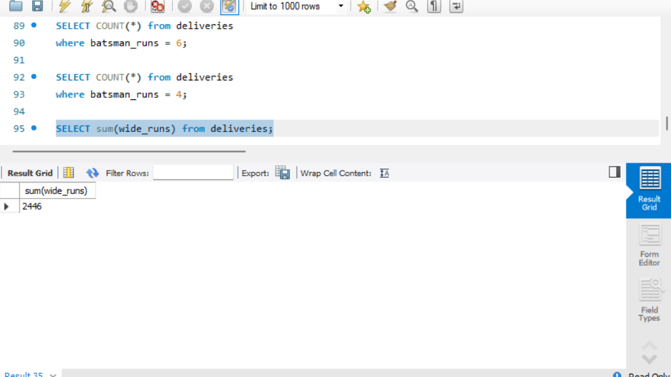

31. Find the total number of no-ball runs in the deliveries table.
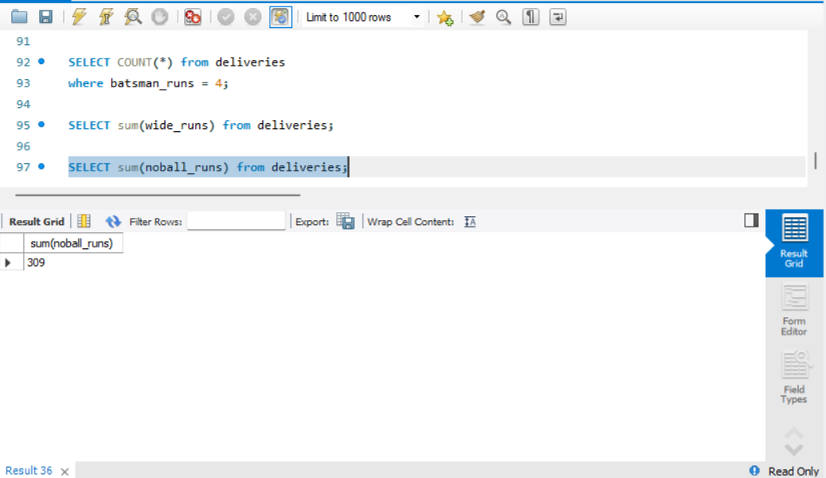

32. Find the total batsman runs scored by each batsman and show the top 10 run scorers.
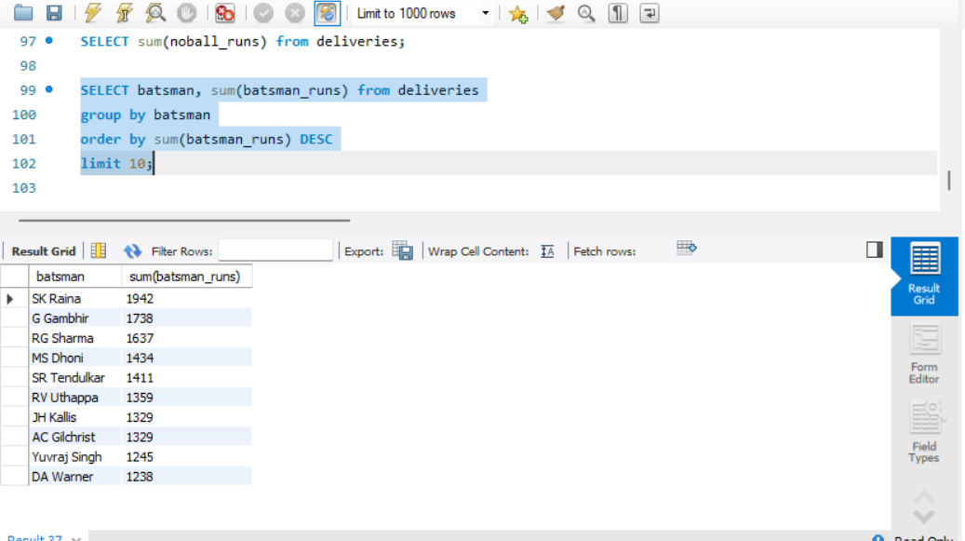

33. Find the number of sixes hit by each batsman and show the top 10 six hitters.
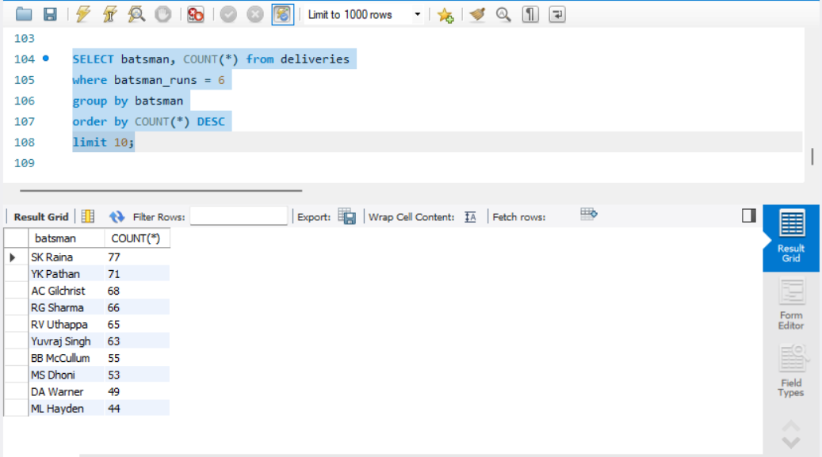

34. Find the number of fours hit by each batsman and show the top 10 four hitters.
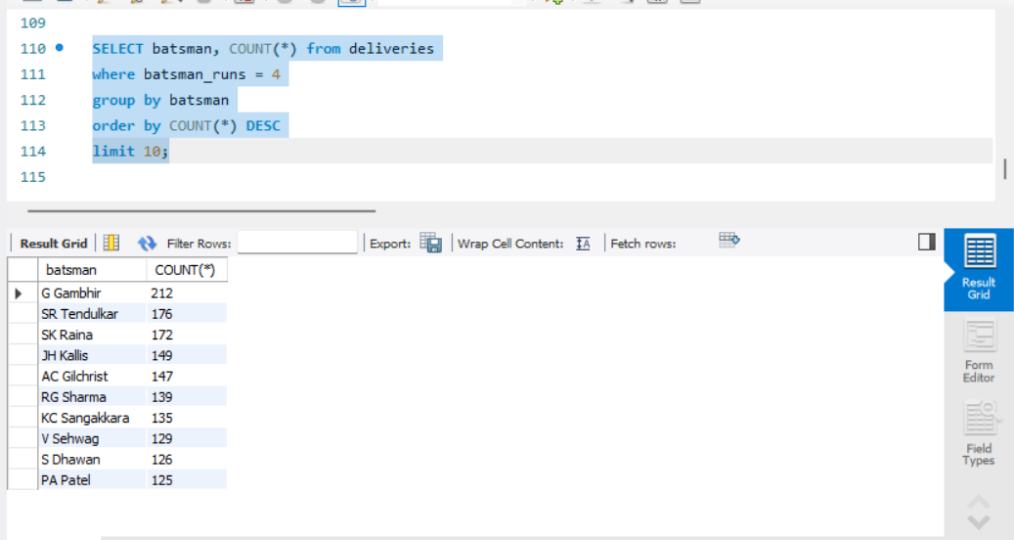

35. Find the total runs scored by each batting team.
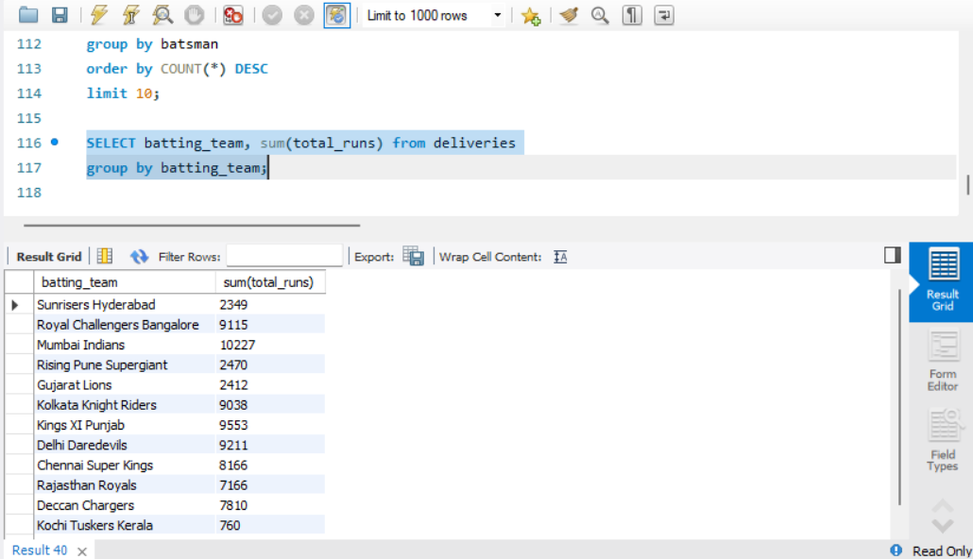

36. Find the total extra runs received by each batting team.
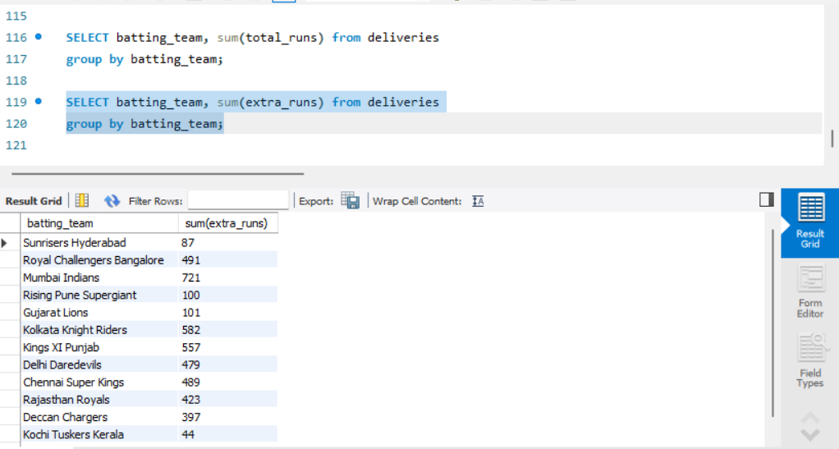

37. Count the number of deliveries bowled by each bowler and show the top 10.
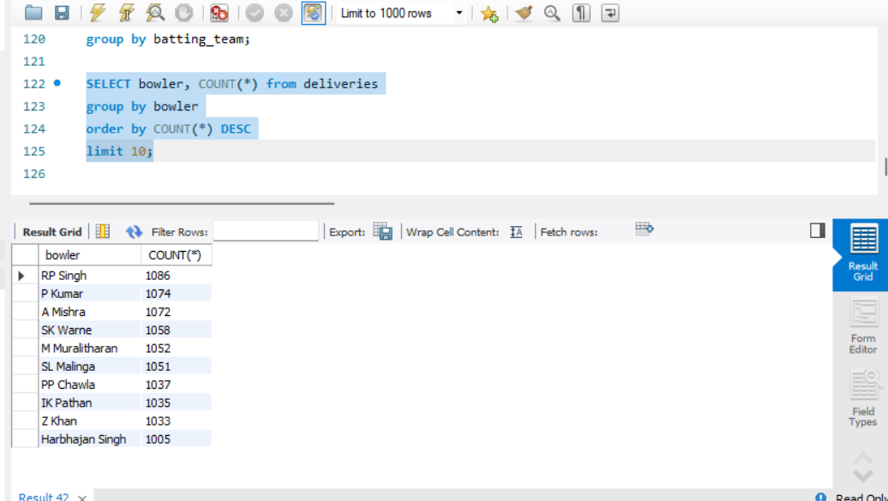

38. Find the total runs conceded by each bowler using total_runs and show the top 10 highest totals.
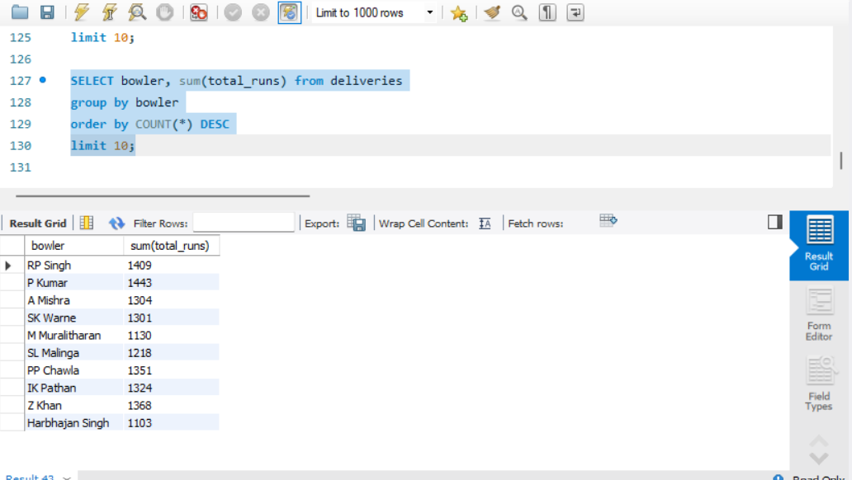

39. Count the number of recorded dismissals for each bowler, excluding run out, and show the top 10.
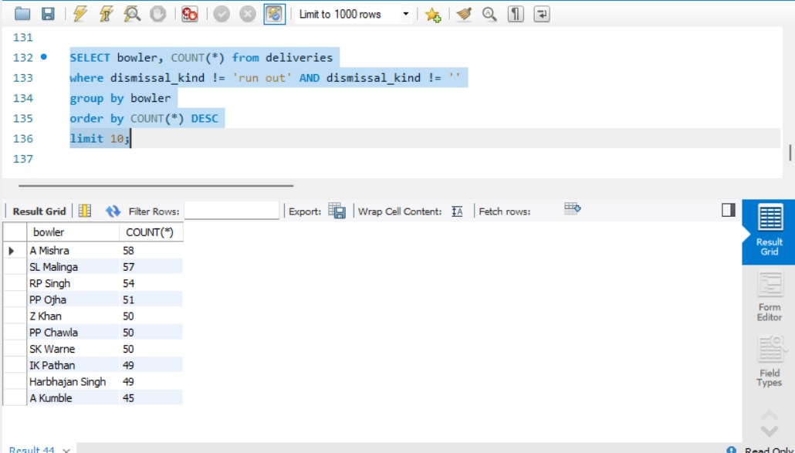

40. Count how many dismissals occurred for each dismissal_kind.
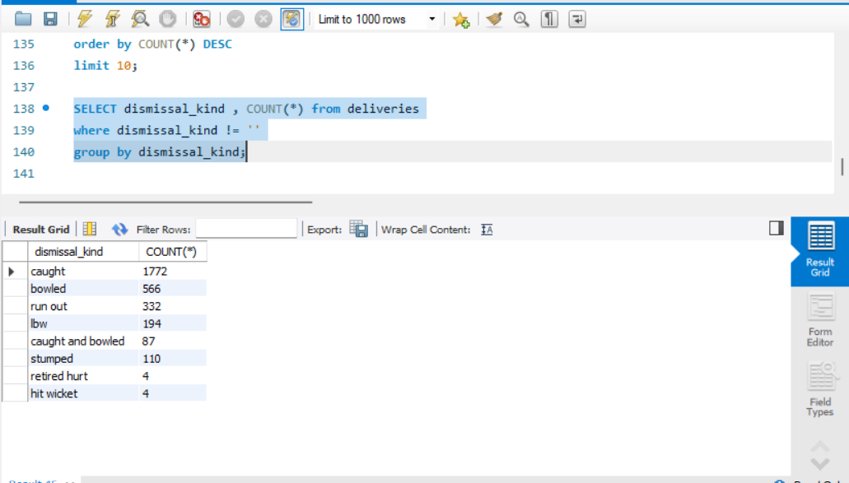

Part D — Analysis Using Both Tables

41. Join matches and deliveries using matches.id = deliveries.match_id and display 20 joined records.
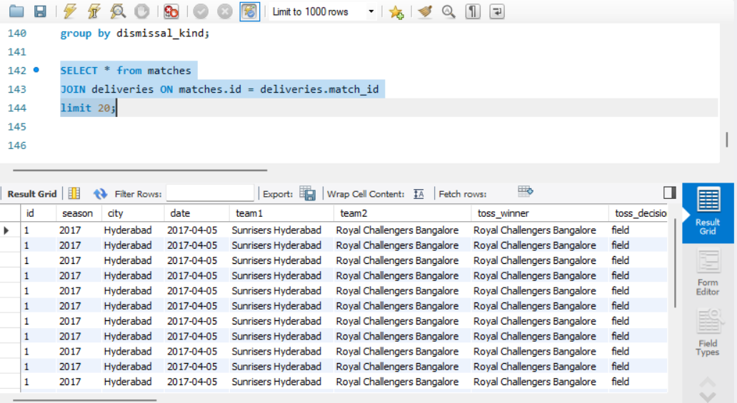

42. Using the joined tables, find the total runs scored in each IPL season.
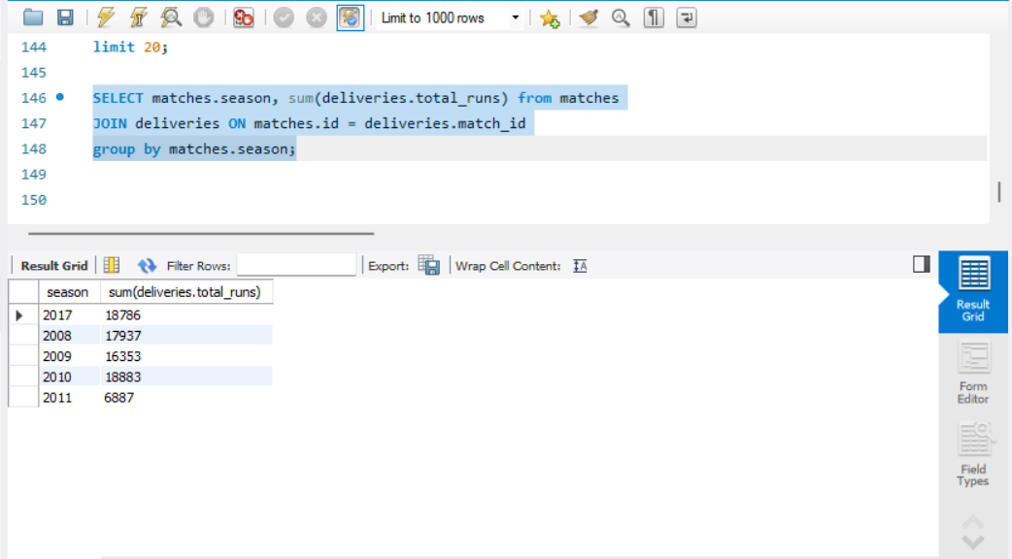

43. Using the joined tables, find the total number of sixes in each season.
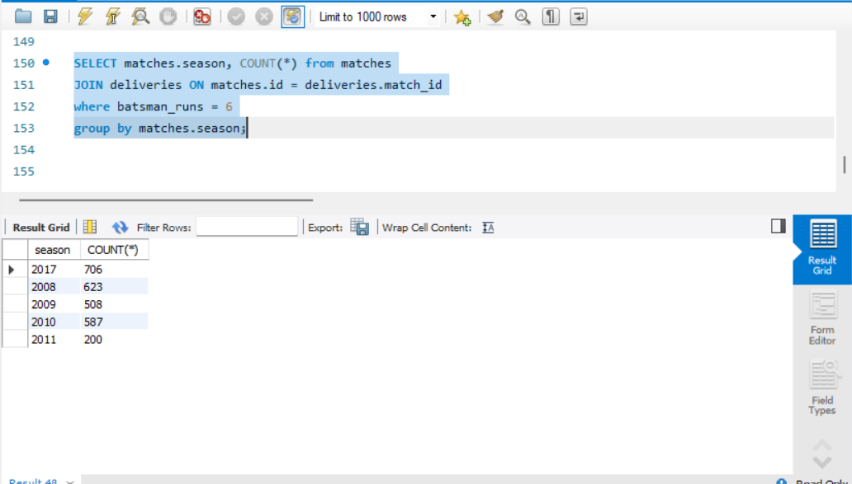

44. Using the joined tables, find the total number of fours in each season.
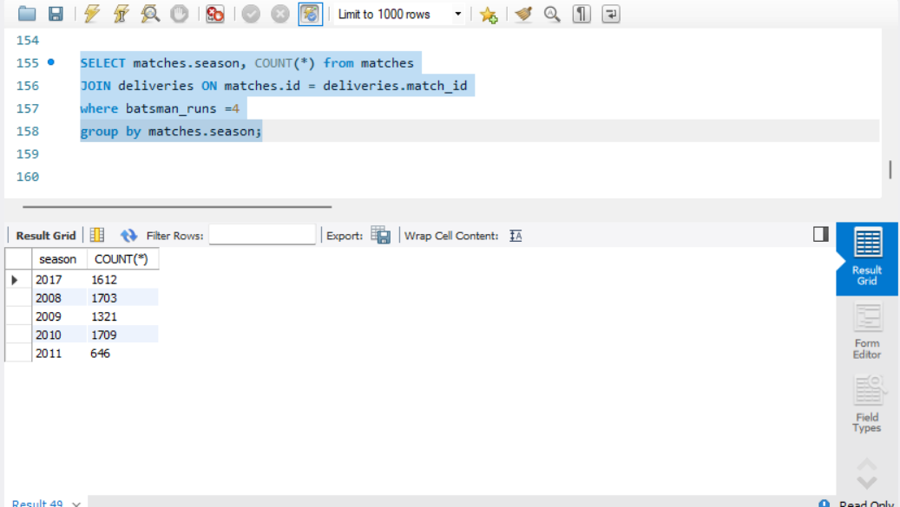

45. Using the joined tables, find the total extra runs in each season.
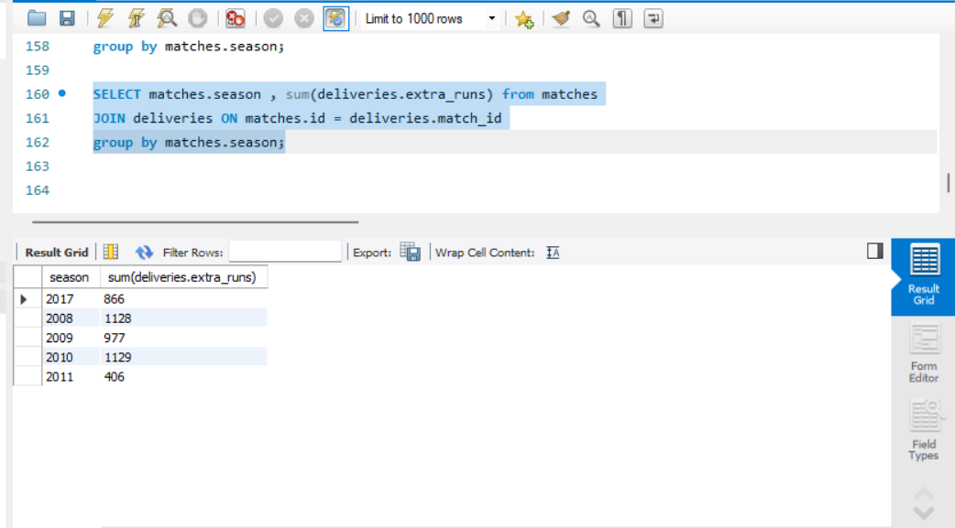

46. Using the joined tables, find total runs scored by each batting team in each season.
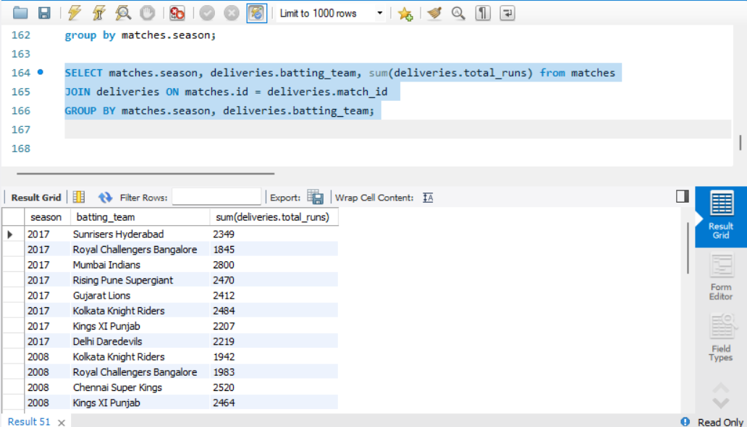

47. Using the joined tables, find the top 10 run scorers in the 2017 season.
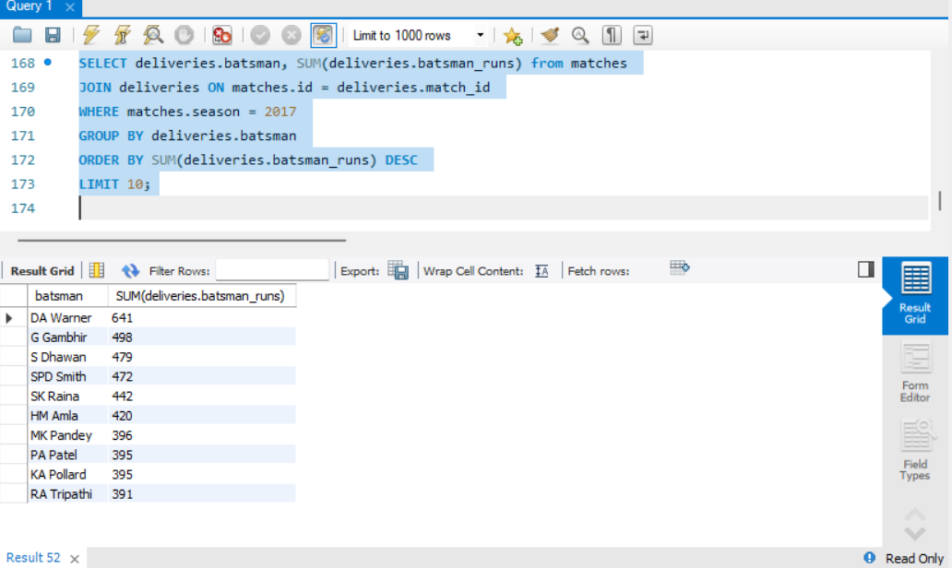

48. Using the joined tables, find the top 10 venues by total runs scored.
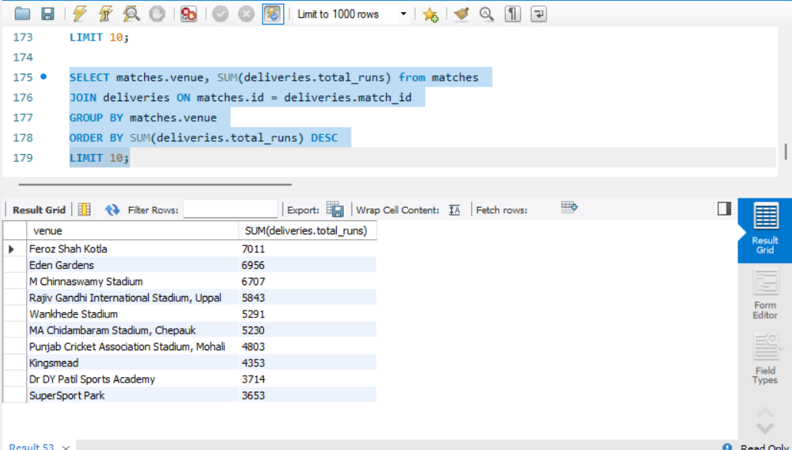

49. Using the joined tables, find the number of recorded dismissals in each season.
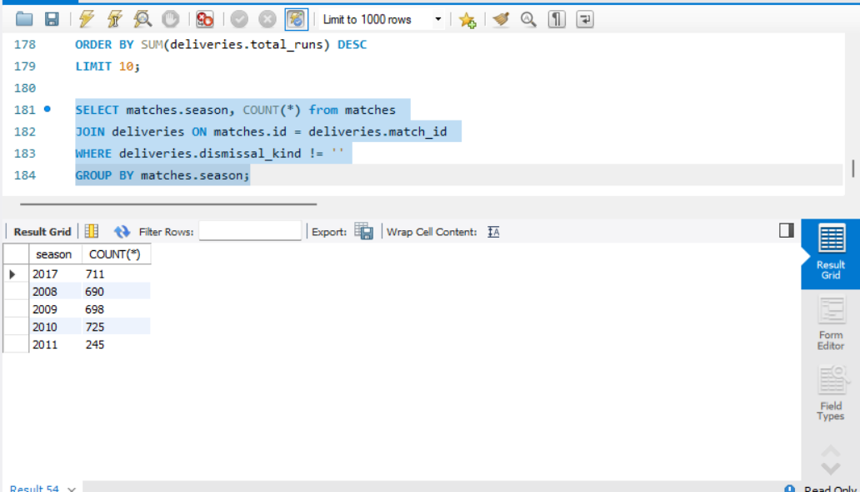

50. Using the joined tables, show each match ID, season, winner, and total runs scored in that match, ordered from highest match total to lowest.
